|  |  |
| --- | --- |
| Brazil humidity prediction  Anjali Mudgal | Abstract  Predicting Relative Humidity at station ID 'A010' in North Brazil by analyzing temperature, precipitation, wind speed, and atmospheric pressure for accurate climate monitoring and forecasting.  Mudgal, Anjali  Time Series Forecasting |

Table of Contents

Table of Figure 2

Table of Equation 4

Table of Code 4

Abstract 4

Introduction 5

Description of the dataset 6

Pre-processing dataset : 7

Daily aggregation 7

Filling the missing values 8

Cleaned Data 8

Plot of Dependent Variable(Relative Humidity(%)) against time 8

ACF/PACF of Relative Humidity(%) 9

Correlation Matrix with Pearson Coefficients 9

Train Test Split 10

Stationarity 11

Time Series Decomposition 12

Base-models 13

Average 13

Naïve 14

Drift 15

Simple Exponential 16

Holt-Winters method 17

Multiple Linear Regression 18

Feature Elimination 18

Dropping Column 18

SVD – Initial 19

VIF – Initial 19

VIF – Final 20

SVD – Final 20

Regression Analysis 21

Hypothesis Test – 22

F Test 22

T Test 22

AIC, BIC, RMSE, R-square, Adjusted R-square 23

ARMA 25

Preliminary model development procedure 25

Checking (1,0) 26

Checking (7,0) 27

Estimating ARMA parameters using Levenberg Marquardt algorithm 29

Forecast Function 29

Diagnostic Analysis 32

Estimated Coefficients and Confidence Interval 32

Roots of Polynomial 33

Covariance Matrix 33

Deep Learning 33

Final Model Selection 34

Summary and Conclusion 35

Limitations 35

References 35

# Table of Figure

Figure 1 Dataset features 6

Figure 2 Station location of the selected dataset 7

Figure 3 Missing Values before and After aggregating data on daily basis 8

Figure 4 Target Variable(Relative Humidity) Series after daily aggregation 8

Figure 5 Relative Humidity after aggregation and filling missing values 9

Figure 6 ACF/PACF of daily data(raw) for 1000 lags, here we can see the seasonality of 365 9

Figure 7 ACF/PACF of daily data with 50 lags 9

Figure 8 Correlation Matrix 10

Figure 9 Train Test Split 11

Figure 10 Stationarity Check on Original Data 11

Figure 11 Original Data ACF/PACF 12

Figure 12 Stationarity Check on Seasonally Differenced data. 12

Figure 13 STL Decomposition 13

Figure 14 Strength of Seasonality and Strength of Trend for our Dataset 13

Figure 15 Forecast using Average Base Model 14

Figure 16 MSE Average 14

Figure 17 MSE Naive 15

Figure 18 MSE for Drift 16

Figure 19 Simple Exponential Smoothing Prediction (alpha = 0.1) 17

Figure 20 MSE for SES 17

Figure 21 Holt Winter Prediction 18

Figure 22 SVD Final and Condition Number 20

Figure 23 Regression Model Summary 21

Figure 24 Hypothesis F Test 22

Figure 25 F Test 22

Figure 26 F Test Hypothesis 22

Figure 27 F test 23

Figure 28 Linear Regression MSE 23

Figure 29 ACF of Residual from Linear Regression 24

Figure 30 Q value for Linear Regression 24

Figure 31 Variance and Mean of Residual for Residual 24

Figure 32 ACF/PACF Seasonally Differenced (365) data 25

Figure 33 GPAC for Seasonally Differenced data 26

Figure 34 ACF Residual with order (1,0) 26

Figure 35 Chi Square Test with initial order(1,0) 27

Figure 36 GPAC of Residual with order (1,0) 27

Figure 37 ACF of Residual with order (7,0) - Final Model 27

Figure 38 ARMA Model (7,0) 28

Figure 39 Coefficients from LM algorithm 29

Figure 40 Parameter Estimates and Confidence Interval 29

Figure 41 Standard deviation of parameter estimates 29

Figure 42 One Step on ARMA(7,0) 31

Figure 43 h step Prediction on order (7,0) 32

Figure 44 Forecasted Error ARMA(7,0) 32

Figure 45 Estimated Coefficients and Confidence Interval 32

Figure 46 Roots of polynomial 33

Figure 47 Covariance Matrix 33

Figure 48 LSTM Predictions 34

Figure 49 Mean Square Error from LSTM 34

# Table of Equation

Equation 1 Strength of Seasonality and Strength of Trend 13

Equation 2 Average Prediction 13

Equation 3 Naive Forecast 14

Equation 4 Naive Forecast 15

Equation 5 Drift Method 15

Equation 6 Forecast using Drift 16

Equation 7 Simple Exponential 16

Equation 8 Holt Winter Equation 17

Equation 10 Model Equation ARMA 29

Equation 11 Forecast Equations 30

# Table of Code

Code 1 VIF Feature Removal 21

Code 2 Forecast Function 30

Code 3 Reverse Transformation 31

Code 4 LSTM Code 33

# **Abstract**

This project focuses on predicting the Relative Humidity in North Brazil, specifically at station ID 'A010'. Relative humidity is influenced by various factors, including temperature, precipitation, wind speed, and atmospheric pressure. Understanding the interplay of these factors is crucial for accurate humidity predictions and gaining insights into seasonal patterns.

Temperature has a significant impact on relative humidity, as warm air can hold more moisture than cool air. Additionally, precipitation, such as rainfall, introduces moisture into the air, affecting humidity levels. Wind speed plays a role in humidity by causing moisture to evaporate more quickly under strong winds. On the other hand, calm conditions allow moisture to linger, resulting in higher humidity levels. Furthermore, atmospheric pressure is associated with humidity, with low-pressure systems often indicating high humidity and high-pressure systems indicating lower humidity percentages.

Through comprehensive time series analysis, considering temperature, precipitation, wind speed, and atmospheric pressure, this study aims to uncover seasonal variations and make accurate predictions of Relative Humidity in North Brazil at station ID 'A010'. The findings from this research will contribute to a better understanding of the factors influencing humidity patterns in the region, enabling more effective climate monitoring and forecasting.

# **Introduction**

In this report, we delve into the analysis of a Brazil humidity dataset and explore various factors that can potentially influence it. Our objective is to employ different models, such as average, drift, naïve, Simple Exponential, Holt Winter, ARMA, Linear Regression, and LSTM, to predict humidity levels. The primary aim is to compare these models and identify the most suitable one that effectively represents the data and facilitates accurate predictions.

To determine the ARMA model, we employ several techniques, including assessing stationarity, analyzing the Autocorrelation Function (ACF) and Partial Autocorrelation Function (PACF), and employing the Generalized Partial Autocorrelation (GPAC) method. Through these steps, we aim to determine the optimal order and equation that best capture the characteristics of the data.

To obtain statistically significant coefficients that accurately represent the data, we utilize the Levenberg Marquardt Algorithm. This algorithm helps us estimate the coefficients that align with the observed data and are deemed statistically significant. These coefficients serve as vital inputs for our prediction model.

Subsequently, using the selected model and obtained information, we conduct predictions for relative humidity. By evaluating the mean square error and performing diagnostic analyses on the residuals, we rigorously assess the model's performance. These evaluations guide us in selecting the most appropriate model from the candidate models for our specific dataset.

Through this comprehensive analysis and model comparison, we aim to identify the optimal model for predicting relative humidity in the given Brazil dataset. The chosen model will not only provide accurate predictions but also enable a deeper understanding of the underlying patterns and factors influencing humidity levels.

# **Description of the dataset**

I have [Climate Weather Surface of Brazil - Hourly](https://www.kaggle.com/datasets/PROPPG-PPG/hourly-weather-surface-brazil-southeast-region) Kaggle dataset for my project. Here we have the following features :

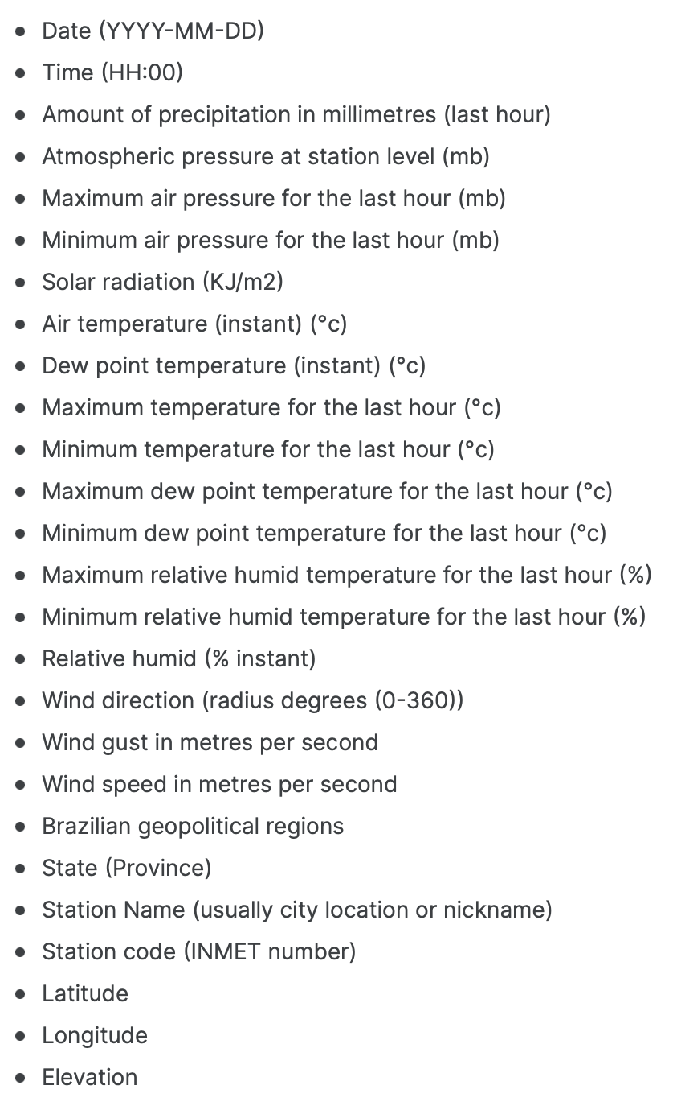

Figure 1 Dataset features

For this time series analysis, we focus on station code 'A010' in North Brazil. Latitude, longitude, and elevation variations influence humidity levels. By examining this dataset, we uncover temporal patterns and understand regional humidity dynamics. This analysis aids local climate monitoring and prediction efforts. Here we can ‘A010’ lies in north-eastern region of Brazil.

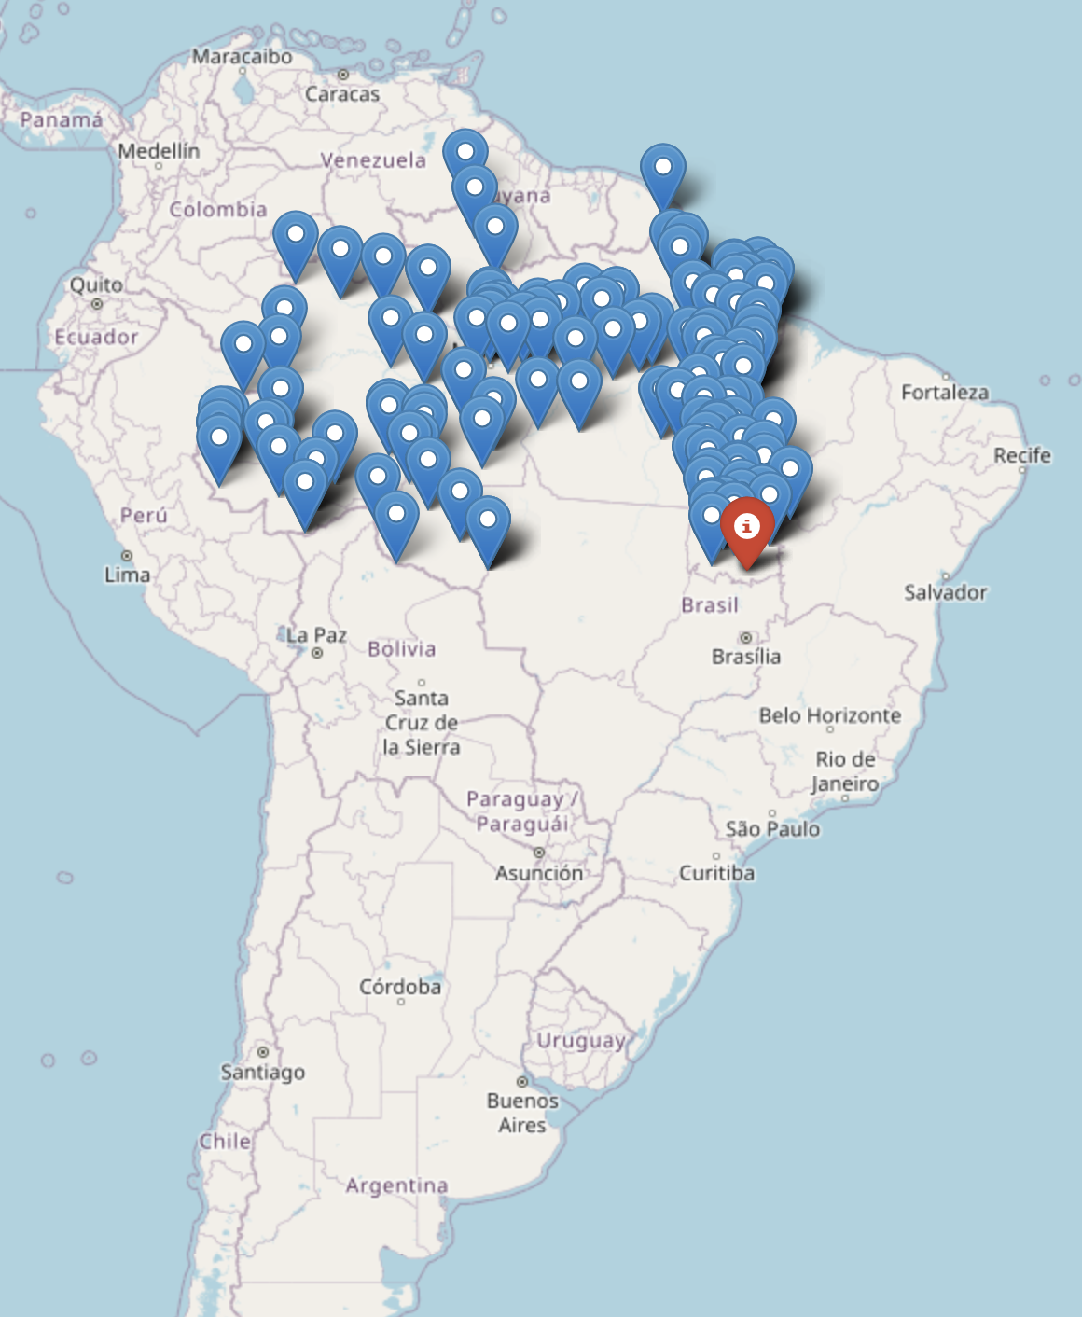

Figure 2 Station location of the selected dataset

With this I would be dropping my location dependent features such as 'region', 'station', 'state', 'latitude', 'longitude', 'height', 'station code'.



This is what the initial time series looks like with hourly data (141648 observations).

## Pre-processing dataset :

### Daily aggregation

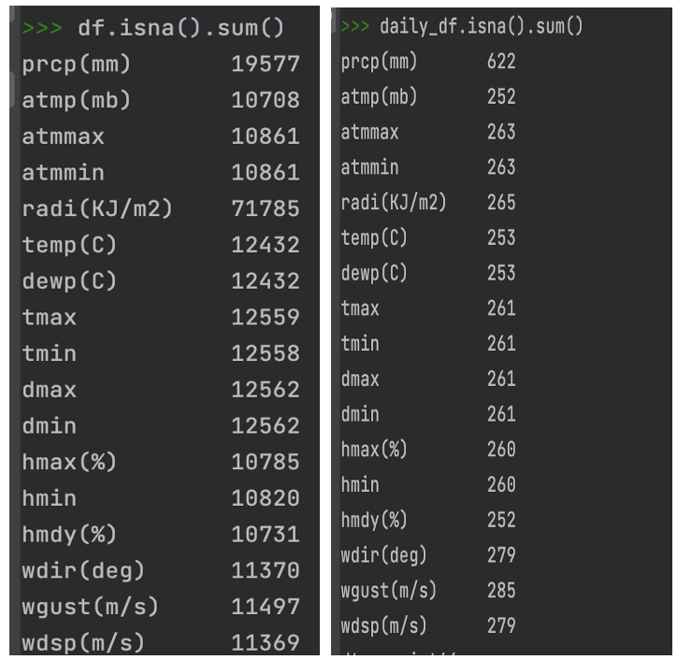

Figure 3 Missing Values before and After aggregating data on daily basis

Since my dataset has a lot of missing value, I am doing a daily aggregation with mean of hourly data.



Figure 4 Target Variable(Relative Humidity) Series after daily aggregation

### Filling the missing values

Since the missing values have now been reduced, I am using spline interpolation to fill in those values. The spline curve consists of multiple polynomial segments, typically cubic polynomials, that smoothly connect the data points.

## Cleaned Data

### Plot of Dependent Variable(Relative Humidity(%)) against time

This is how my Relative Humidity (%) looks like against time(daily) now. I have 5902 observations.



Figure 5 Relative Humidity after aggregation and filling missing values

### ACF/PACF of Relative Humidity(%)



Figure 6 ACF/PACF of daily data(raw) for 1000 lags, here we can see the seasonality of 365

Figure 7 ACF/PACF of daily data with 50 lags

Here we can notice, the seasonality of 365 and an AR of order (1,0)

### Correlation Matrix with Pearson Coefficients

This is how relative humidity(%) is correlated with other variables. As we can notice here, the high values of correlation coefficients are with hmin, hmax( these are max and min humdity), temp(C) which is temperature in Celsius, tmin(C), tmax(C). Dmin, dmax, dewp(dew point temperature min, max and instant in Celsius).

Also from other correlation in matrix we can notice some correlations.



Figure 8 Correlation Matrix

### Train Test Split

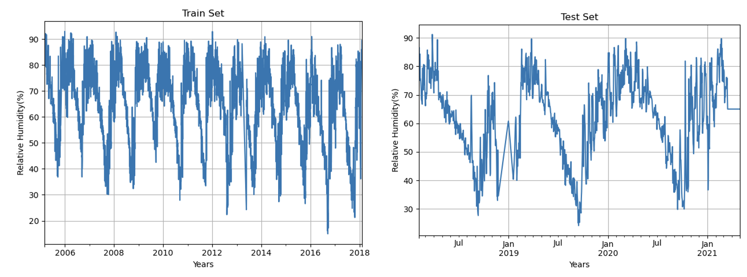

Figure 9 Train Test Split

The training dataset consists of 4721 observations, while the test set contains 1181 observations. It is worth noting that in the test set, some missing values have been filled using interpolation techniques. This interpolation method may lead to a slightly higher error than anticipated when evaluating the model's performance on the test data. It is important to consider this potential impact of interpolated values when interpreting the accuracy of the model's predictions on the test set.

# Stationarity

To check the stationarity of raw data I would be using rolling mean, rolling variance, ADF and KPSS tests. As we can see from the results of rolling variance and KPSS test, the dataset is a marginally stationary.

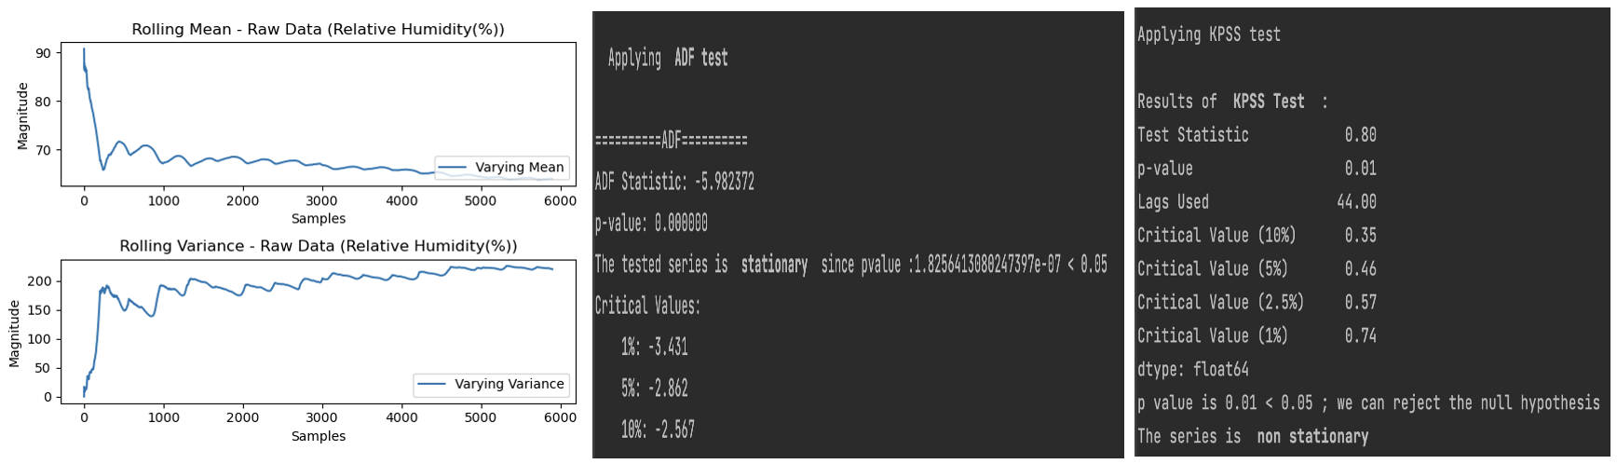

Figure 10 Stationarity Check on Original Data

By looking at the results and ACF/PACF , I am performing a seasonal differencing of 365.

Figure 11 Original Data ACF/PACF

After seasonal differencing of 365.

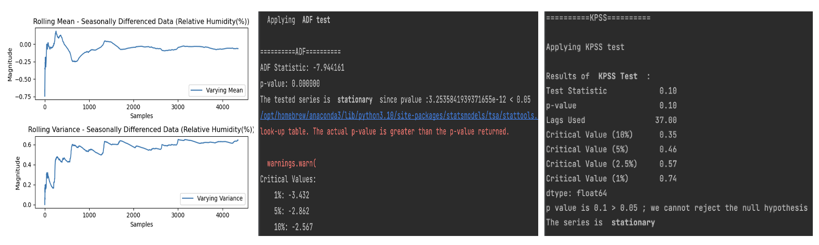

Figure 12 Stationarity Check on Seasonally Differenced data.

As we can see clearly here the series is stationary.

# Time Series Decomposition

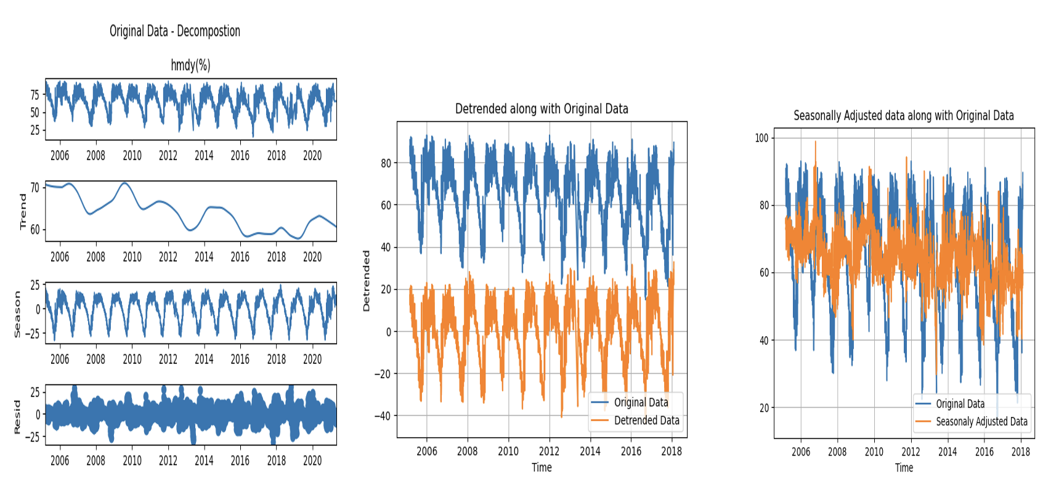

Figure 13 STL Decomposition

Equation 1 Strength of Seasonality and Strength of Trend

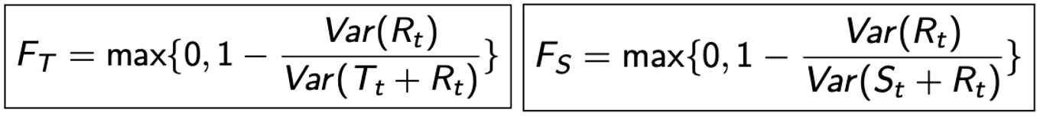

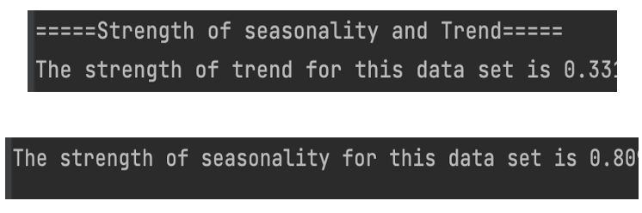

Figure 14 Strength of Seasonality and Strength of Trend for our Dataset

As we can see the detrended and original data are almost similar and the value for trend is very low.

Also the high value of seasonality makes sense, since this dataset is highly seasonal.

From the STL decomposition we can see that the dataset is seasonal with the strength of seasonality as 0.81.

# Base-models

## Average

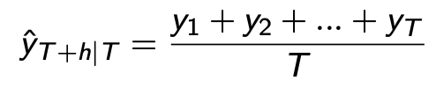

Equation 2 Average Prediction

Figure 15 Forecast using Average Base Model

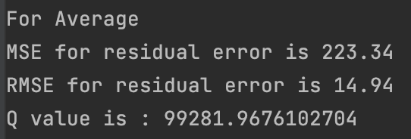

Figure 16 MSE Average

## Naïve

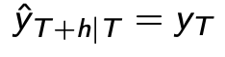

Equation 3 Naive Forecast

Equation 4 Naive Forecast

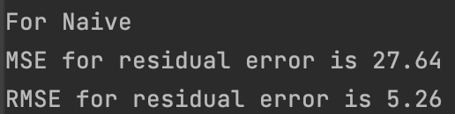

Figure 17 MSE Naive

## Drift

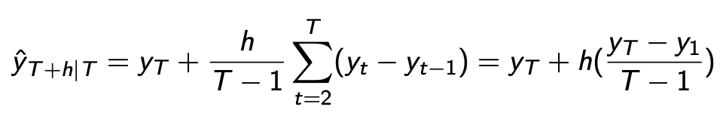

Equation 5 Drift Method

Equation 6 Forecast using Drift

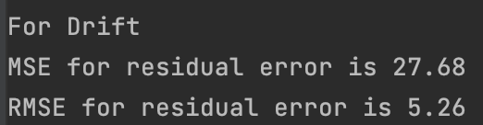

Figure 18 MSE for Drift

## Simple Exponential

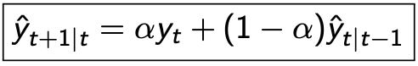

Equation 7 Simple Exponential

Best results are with alpha = 0.1.

Figure 19 Simple Exponential Smoothing Prediction (alpha = 0.1)

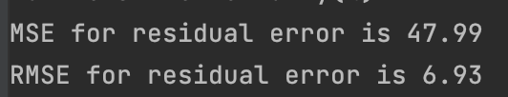

Figure 20 MSE for SES

Base models are performing bad for the test data and thus we will not use them.

## Holt-Winters method

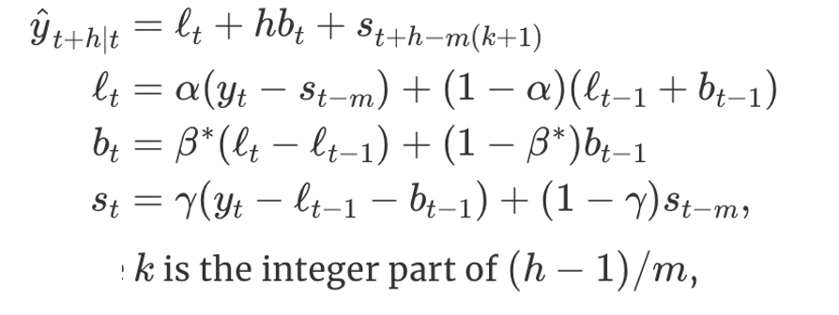

Equation 8 Holt Winter Equation



Figure 21 Holt Winter Prediction

Holt Winter Method is performing the best since predictions are close to the original test data, and here we can see the Root mean square error is 19

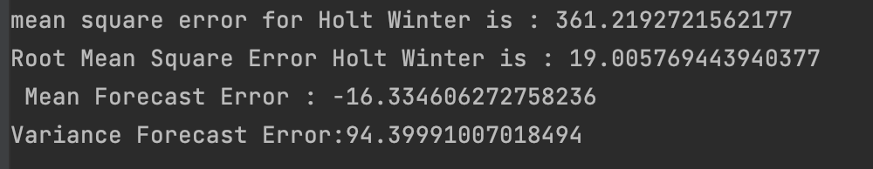



As we can see here that holt Winter is able to capture the dataset well and is giving good results for my datset. The reason it captures the seasonality well.

# Multiple Linear Regression

## Feature Elimination

### Dropping Column

Since we are predicting Relative Humidity(%) (instant) for our dataset dropping minimum, maximum humidity as well.

### SVD – Initial

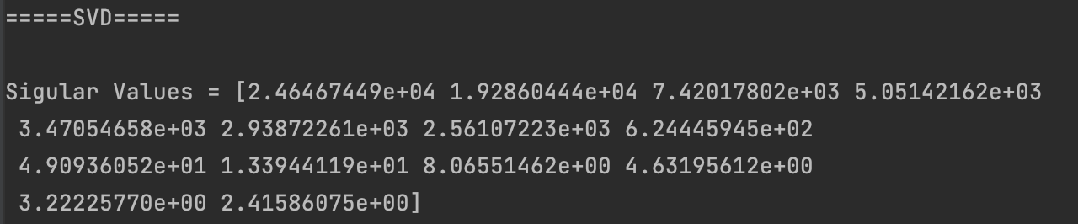

In the SVD, we can see a lot of values are close to 0, which means there is some collinearity in the dataset.

### VIF – Initial

Some of the VIF values are more than even 100, so I have eliminated the features one by one, after checkingt the vif values of the remaining features

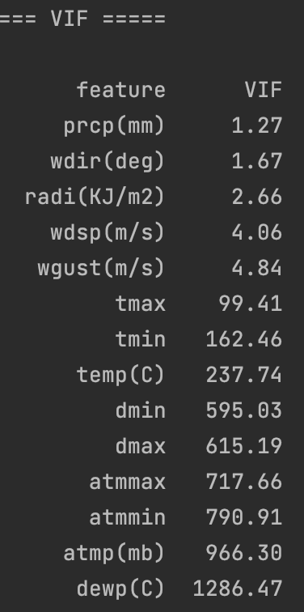

Table 1 VIF Values Initial

### VIF – Final

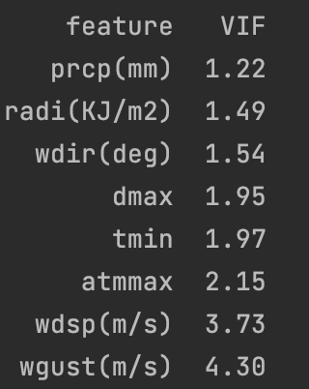

Table 2 VIF Values Final

### SVD – Final

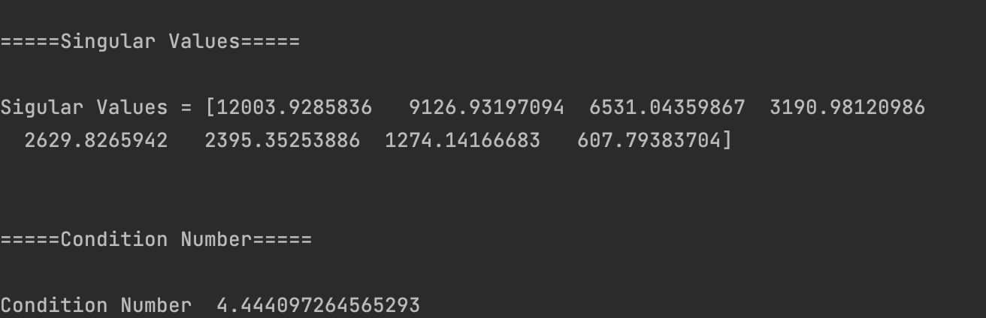

Figure 22 SVD Final and Condition Number

Since the SVD values are now not close to 0 and also the condition number is very low we can see that there is no more collinearity left in the dataset.

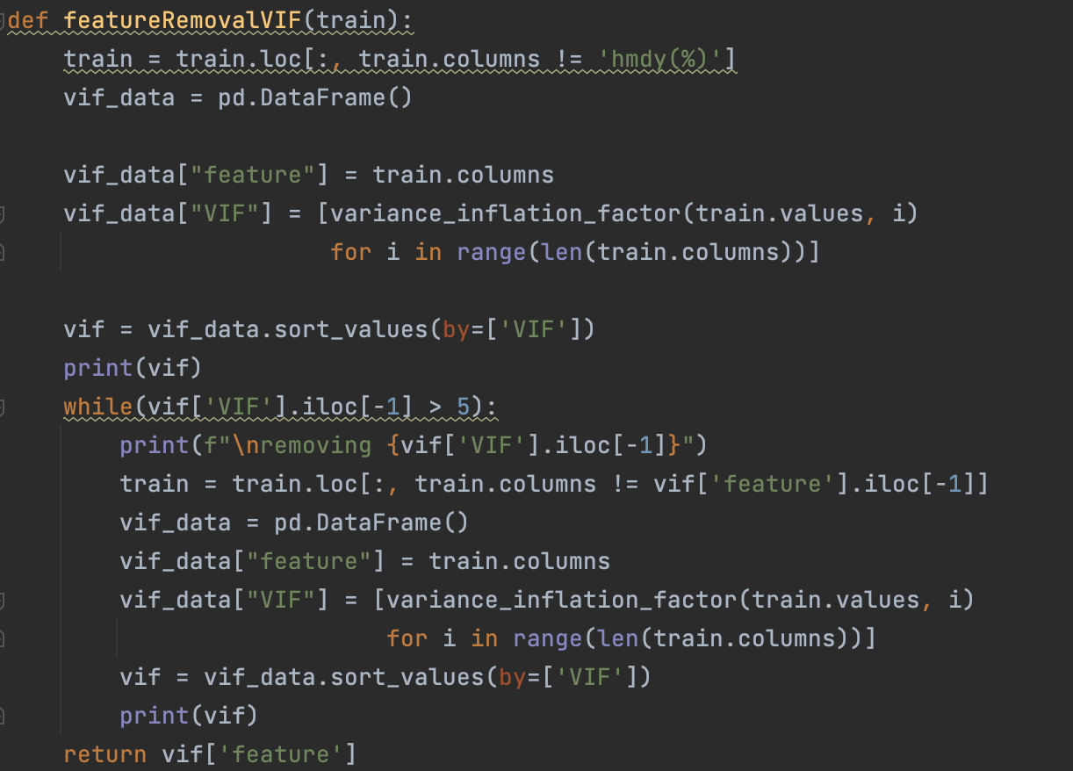

Code 1 VIF Feature Removal

## Regression Analysis

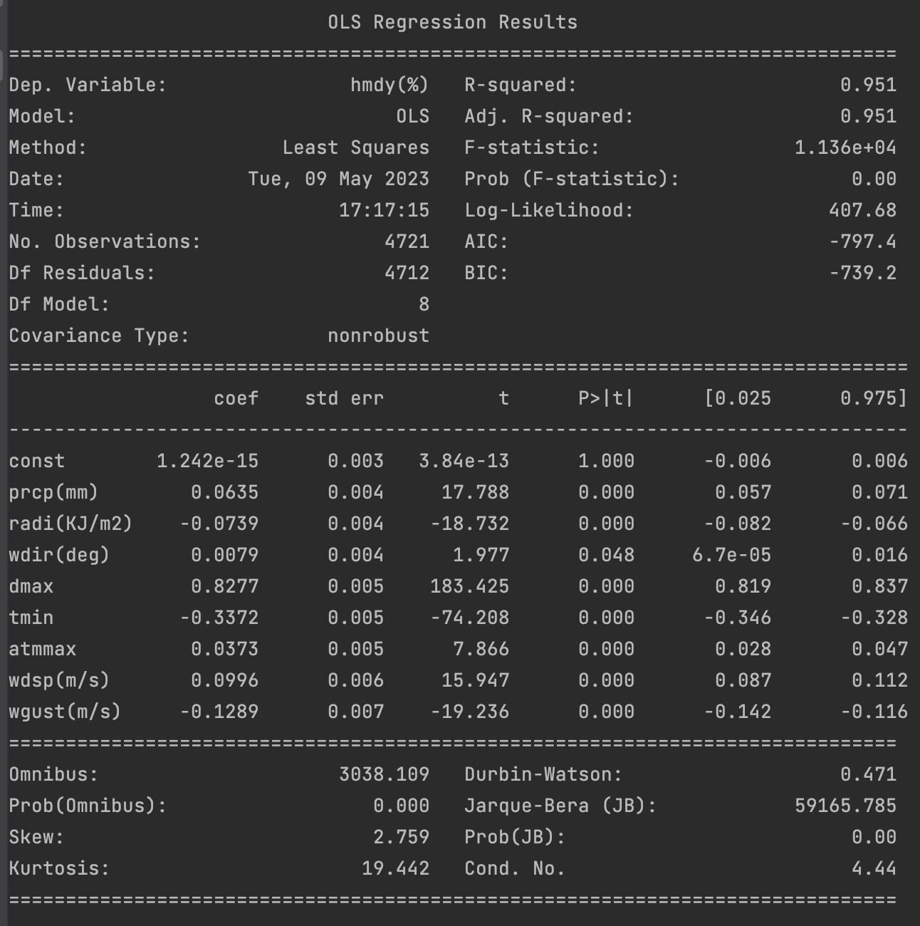

Figure 23 Regression Model Summary

95% of variance in this dataset is explained by the features( prcp(mm) precipitation), radi(KJ/m2) is Solar Radiation, wdir(deg) is wind direction, dmax is (maximum dew point), tmin is minimum temperature, atmmax is maximum atmospheric pressure in (mb), wdsp(m/s) is wind speed and wgust(m/s) is wind gust. Wind gust refers to a brief increase in wind speed above the prevailing or average wind speed at a particular location

Here we can see that the relative humidity is depending on the precipitaion, solar radiation, wind direction, atmospheric pressure, temperature and sudden increase or decrease in wind speed.

## Hypothesis Test –

### F Test

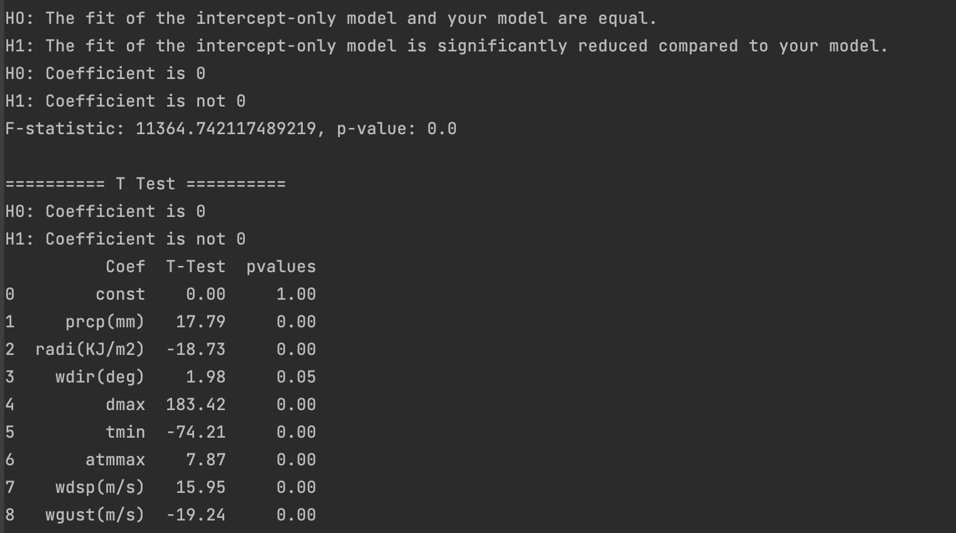

Figure 24 Hypothesis F Test



Figure 25 F Test

From the F Test we can see this model is better than the intercept only model.

P value less than 0 so we can reject our null hypothesis and this this model performs better than null model.

### T Test



Figure 26 F Test Hypothesis



Figure 27 F test

From the T Test we can see the coefficients are significant since p value is < 0.

## AIC, BIC, RMSE, R-square, Adjusted R-square

Our adjusted R2 and R2 are similar so the model has learned the train data well. When I tried to remove any other feature, there was a decrease in my R2 and adjusted R2 so I will stick with this model.

As we can notice here, that AIC and BIC values are pretty low which is a good thing since AIC and BIC take into account the model's likelihood of fitting the data and penalize more complex models that may be overfitting the data. Therefore, lower AIC and BIC values suggest that a model provides a better balance between goodness of fit and complexity.

#### MSE

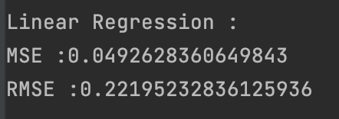

Figure 28 Linear Regression MSE

#### ACF of residuals



Figure 29 ACF of Residual from Linear Regression

#### Q value



Figure 30 Q value for Linear Regression

The model is not generalized properly. High value.

#### Variance and mean of residual

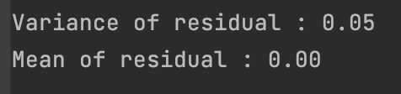

Figure 31 Variance and Mean of Residual for Residual

# ARMA

## Preliminary model development procedure

Figure 32 ACF/PACF Seasonally Differenced (365) data

From the ACF/PACF we can see a tail off in ACF, and cut off at 1 for pacf. This could be an ARMA(1,0).

Looking into GPAC

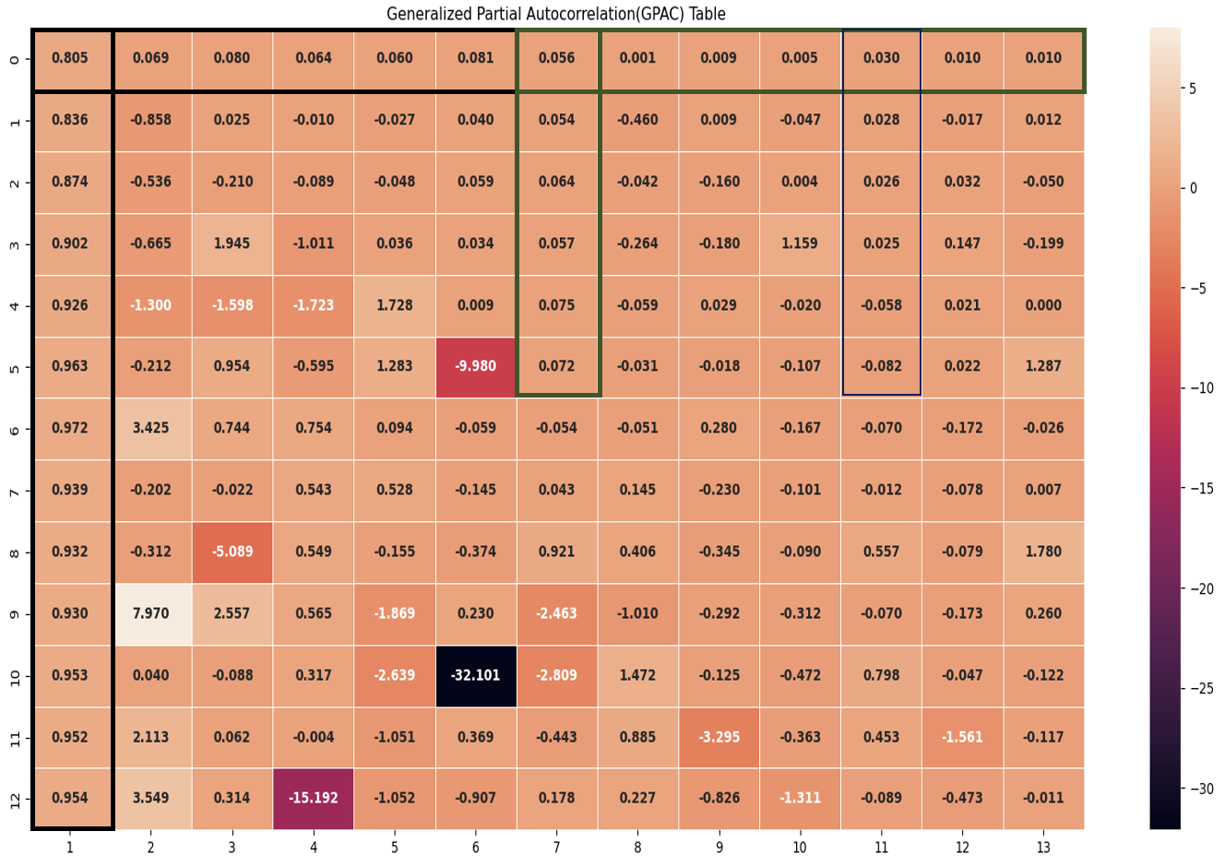

Figure 33 GPAC for Seasonally Differenced data

From the GPAC we can see a potential order of (1,0), (7,0) and (11,0).

### Checking (1,0)

Figure 34 ACF Residual with order (1,0)

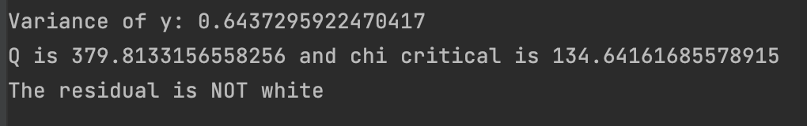

Figure 35 Chi Square Test with initial order(1,0)

Residual is not white.

So we will pass this residual again to the GPAC, and try to find the order. So that we can simply add that order to capture the remaining correlations left in the dataset.

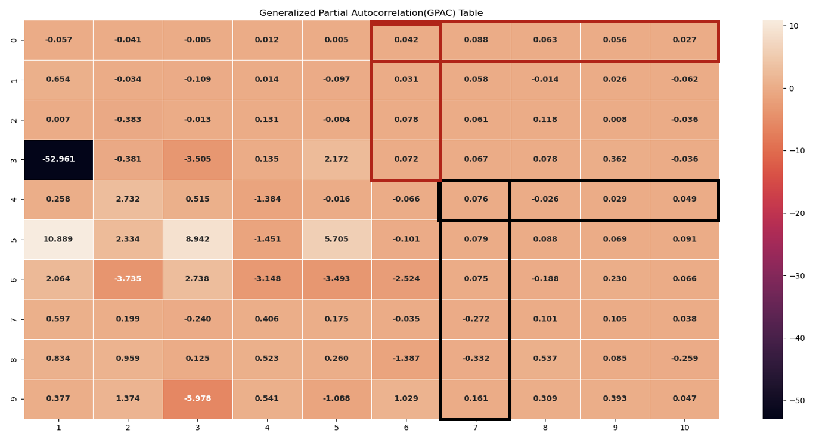

Figure 36 GPAC of Residual with order (1,0)

Here we can see an order of (6,0) and (7,4).

Adding this to our original order((1,0) + (6,0)) we have (7,0) which is the second order that we found in our original GPAC

### Checking (7,0)

After taking order as **(7,0)** we are getting white noise as residual.

Figure 37 ACF of Residual with order (7,0) - Final Model



From the Q statistics also, we can see that the residual is white which means the model has captured the information well.

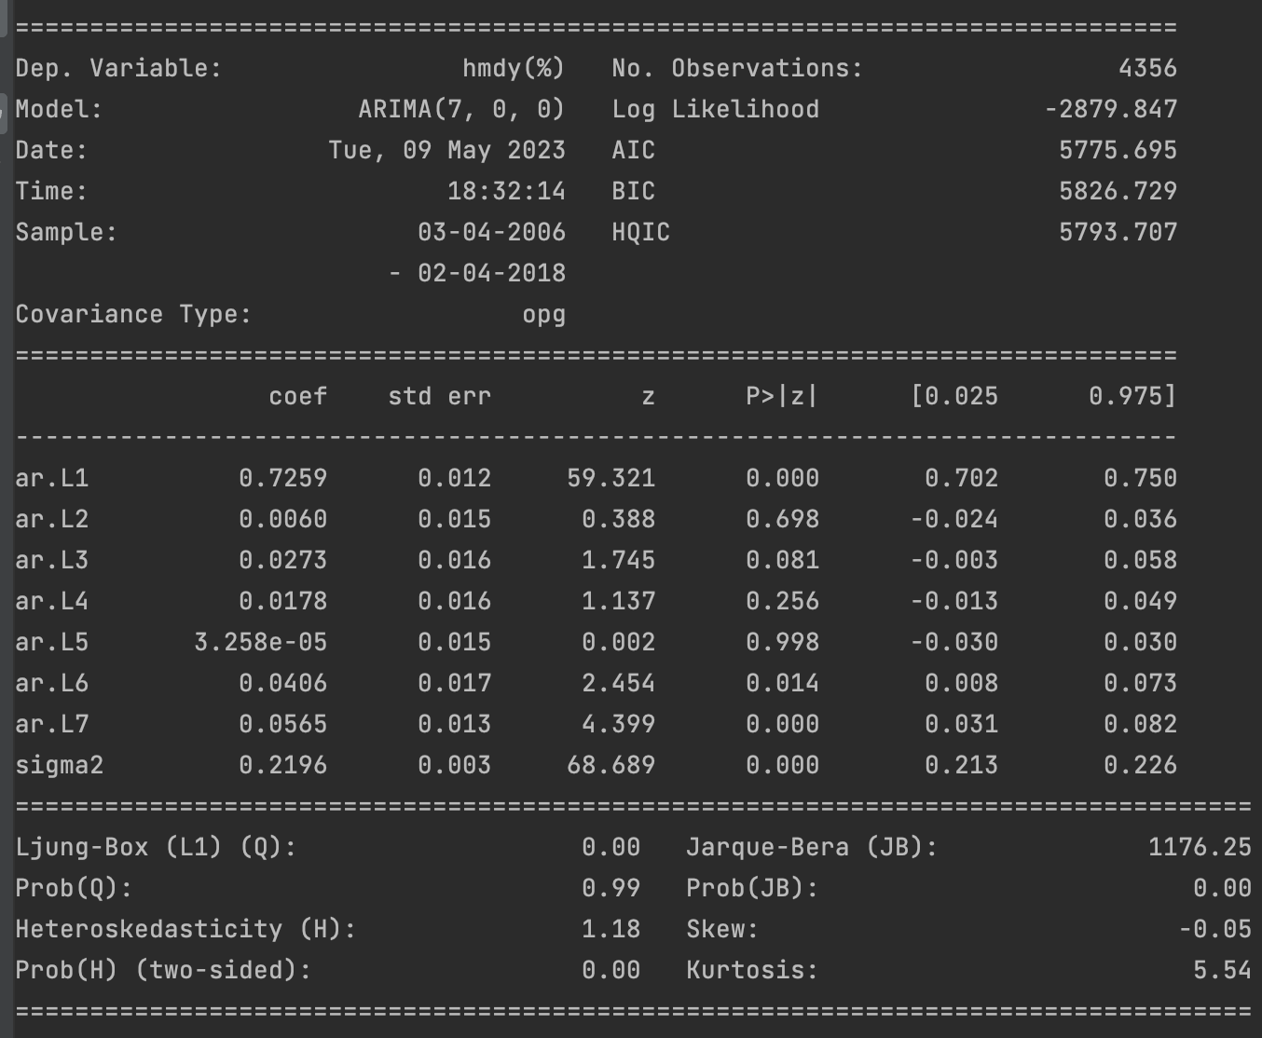

Figure 38 ARMA Model (7,0)

This is the final model that we have using order as (7,0)

## Estimating ARMA parameters using Levenberg Marquardt algorithm

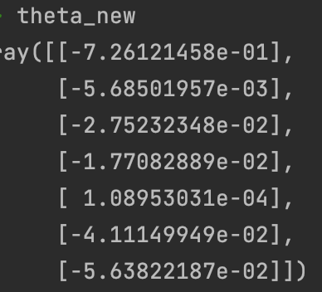

Figure 39 Coefficients from LM algorithm

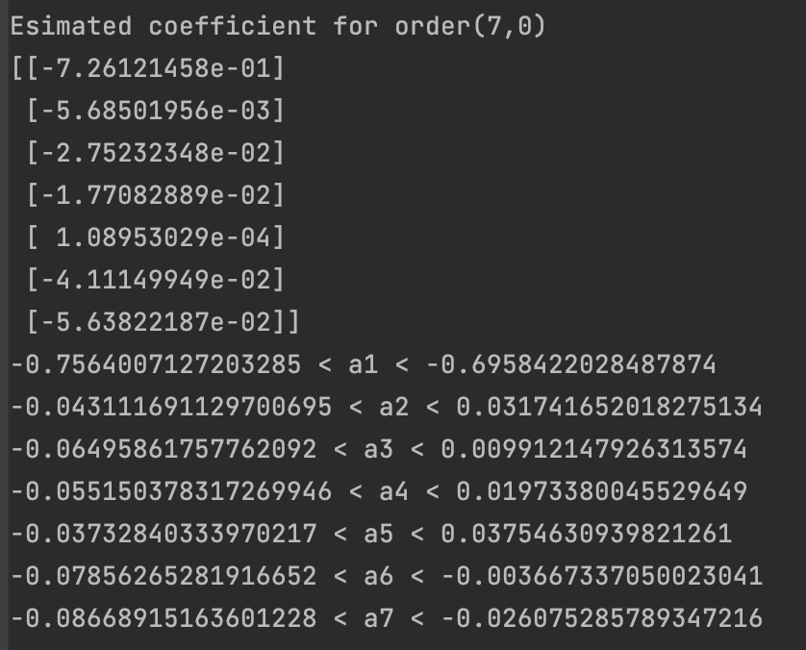

Figure 40 Parameter Estimates and Confidence Interval



Figure 41 Standard deviation of parameter estimates

Here we can observe that the following coefficient have 0 in there confidence interval of so they would become insignificant a2, a3, a4 and a5.

Using the above information we have the following forecast function

## Forecast Function



Equation 10 Model Equation ARMA

Using this forecast function we can perform h step prediction.

The equations would be

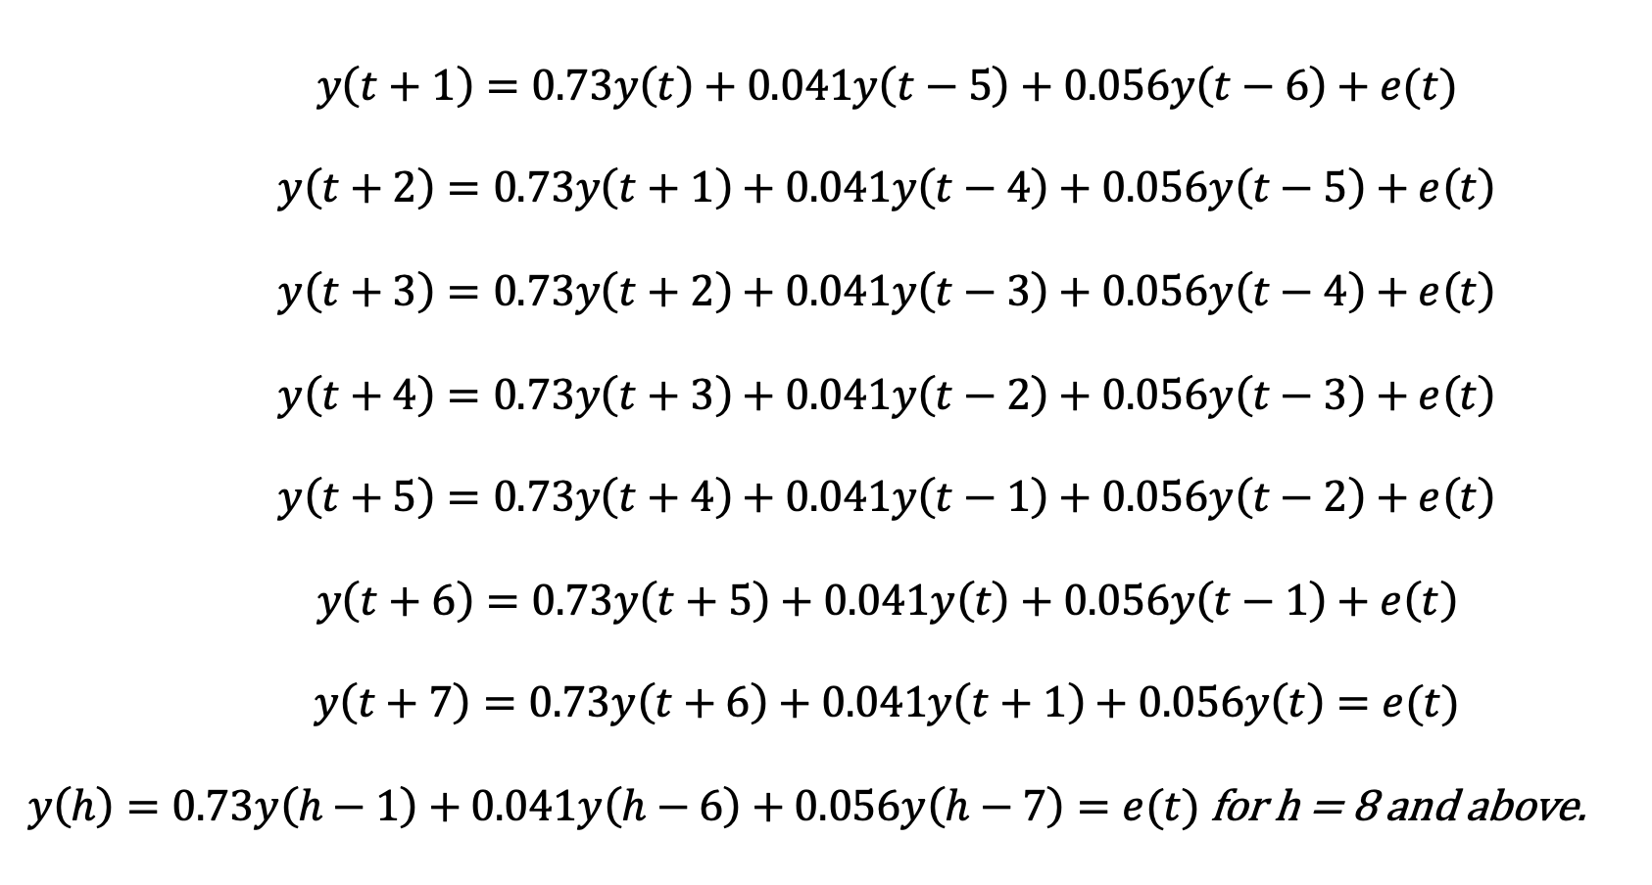

Equation 11 Forecast Equations

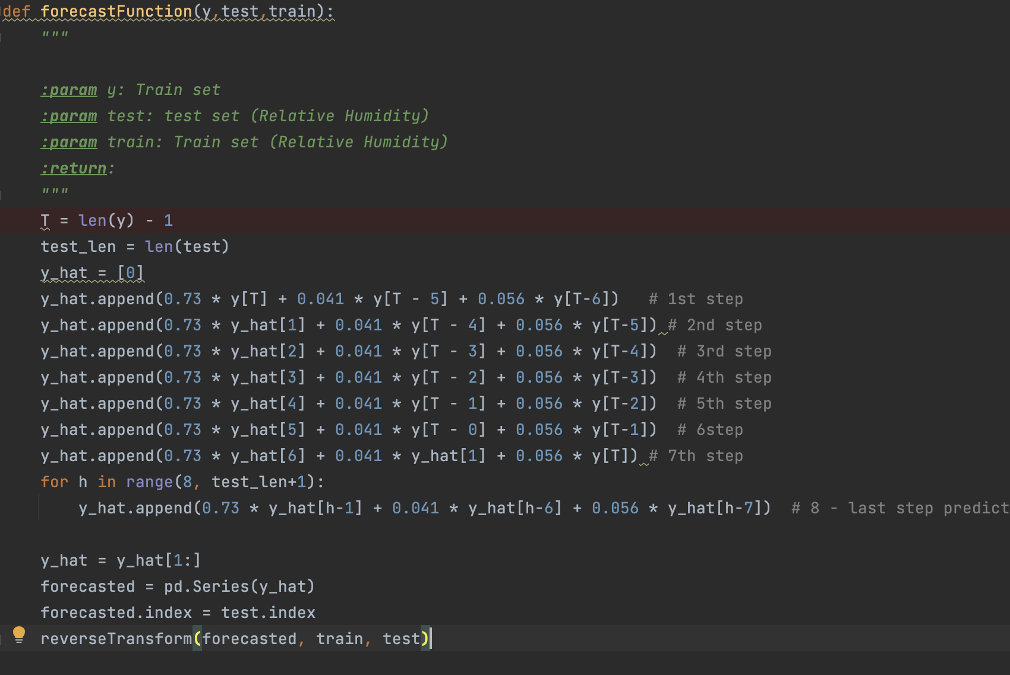

Code 2 Forecast Function

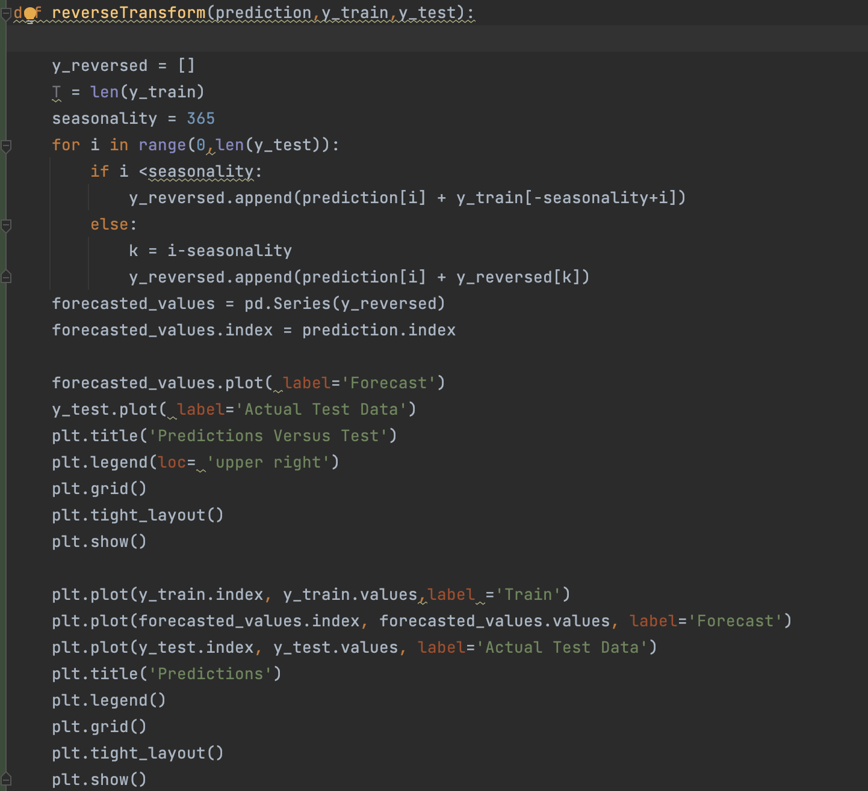

Code 3 Reverse Transformation

Figure 42 One Step on ARMA(7,0)



Figure 43 h step Prediction on order (7,0)

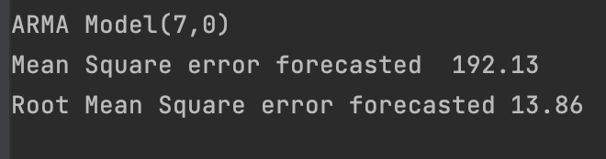

Figure 44 Forecasted Error ARMA(7,0)

Since the model equation and prediction was on differenced data, I have reversed transformed my dataset to get original values.

## Diagnostic Analysis

### Estimated Coefficients and Confidence Interval



Figure 45 Estimated Coefficients and Confidence Interval

### Roots of Polynomial

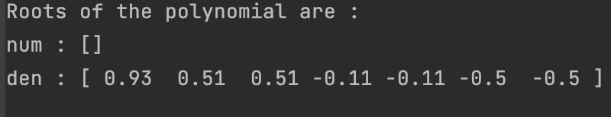

Figure 46 Roots of polynomial

There is no zero pole cancellation.

### Covariance Matrix

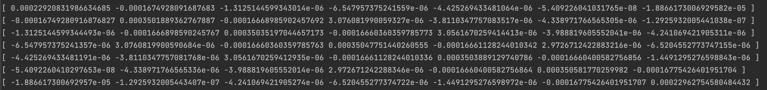

Figure 47 Covariance Matrix

Since the residual is white the model has captured all information and is unbiased.

I tried to use SARIMA with the order of (1,365) for my dataset but due to computational requirements I was not able to use it. For all other models ARMA(7,0) performed best for my dataset.

# Deep Learning

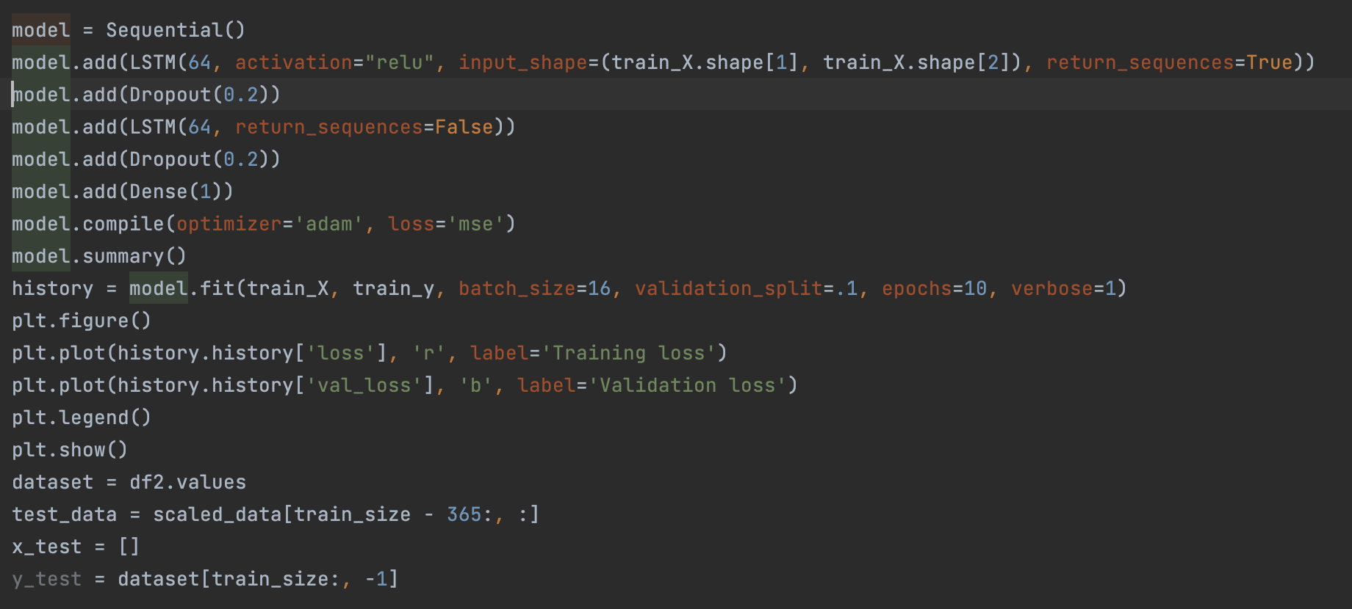

Code 4 LSTM Code

Figure 48 LSTM Predictions

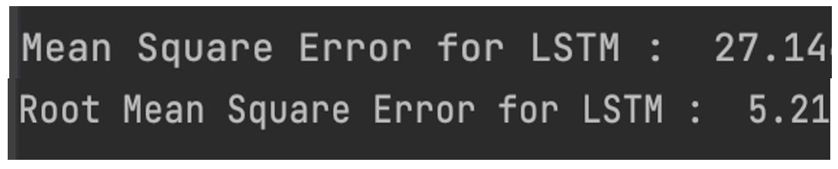

Figure 49 Mean Square Error from LSTM

# Final Model Selection

Final model would be LSTM and ARMA model since they have the lowest MSE.

From the traditional model ARMA Is performing the best

Overall LSTM is performing best.

My best performing model is :

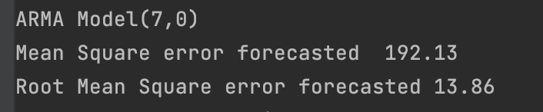





As we can see the best performing model is LSTM and then it’s the ARMA Model.

As residual in ARMA model is white and the mean square error is also low, as compared to other models I would pick ARMA Model.

# Summary and Conclusion

* Dataset is highly seasonal.
* Holt Winter performs well on seasonal dataset.
* LSTM outperforms other models.
* Best traditional model is ARMA(7,0).

# Limitations

* ACF/PACF: The ACF and PACF analysis suggests an order of (1,365) for the best model representation based on the raw dataset's autocorrelation and partial autocorrelation patterns.
* SARIMA Limitation: Running a SARIMA model with such high seasonality (365) is not feasible due to computational constraints or other limitations.
* Interpolation and Errors: Due to the presence of missing values, interpolation has been used to fill in the gaps. However, interpolation can introduce some errors that might affect the accuracy of the predictions.
* Time-dependent Independent Variables: In linear regression, when the independent variables are also time-dependent, making predictions beyond one step ahead becomes challenging due to assumptions about known future values of the independent variables.

# References

* Hyndman, R.J., & Athanasopoulos, G. (2018). Forecasting: Principles and Practice (2nd edition). OTexts. <https://otexts.com/fpp2/holt-winters.html#>
* statsmodels.regression.linear_model.OLS - statsmodels 0.15.0 (+6). (n.d.). <https://www.statsmodels.org/devel/generated/statsmodels.regression.linear_model.OLS.html>